WEEK 7: REACT

S.NO:1 EX : 9 Create a React Application named “cricketapp” with the following components:

SOLUTION CODE:

**ListofPlayers.jsx:**

import React from 'react';

const ListofPlayers = () => {

const players = [

{ name: 'Virat Kohli', score: 95 },

{ name: 'Rohit Sharma', score: 80 },

{ name: 'KL Rahul', score: 67 },

{ name: 'Shubman Gill', score: 73 },

{ name: 'Rishabh Pant', score: 45 },

{ name: 'Hardik Pandya', score: 76 },

{ name: 'Ravindra Jadeja', score: 50 },

{ name: 'Jasprit Bumrah', score: 30 },

{ name: 'Mohammed Shami', score: 65 },

{ name: 'Suryakumar Yadav', score: 85 },

{ name: 'Yuzvendra Chahal', score: 60 }

];

const below70 = players.filter(player => player.score < 70);

return (

<div>

<h2>All Players:</h2>

<ul>

{players.map((player, index) => (

<li key={index}>{player.name} - {player.score}</li>

))}

</ul>

<h2>Players with Score below 70:</h2>

<ul>

{below70.map((player, index) => (

<li key={index}>{player.name} - {player.score}</li>

))}

</ul>

</div>

);

};

export default ListofPlayers;

IndianPlayers.jsx:

import React from 'react';

const IndianPlayers = () => {

const team = ['Kohli', 'Rohit', 'Rahul', 'Pant', 'Bumrah', 'Shami'];

const oddPlayers = team.filter((_, index) => index % 2 !== 0);

const evenPlayers = team.filter((_, index) => index % 2 === 0);

const [first, second, third, fourth, fifth, sixth] = team;

const T20players = ['Dhoni', 'Kohli', 'Raina'];

const RanjiTrophyPlayers = ['Pujara', 'Rahane'];

const mergedPlayers = [...T20players, ...RanjiTrophyPlayers];

return (

<div>

<h2>Odd Team Players:</h2>

<ul>

{oddPlayers.map((player, index) => (

<li key={index}>{player}</li>

))}

</ul>

<h2>Even Team Players:</h2>

<ul>

{evenPlayers.map((player, index) => (

<li key={index}>{player}</li>

))}

</ul>

<h2>Merged T20 and Ranji Trophy Players:</h2>

<ul>

{mergedPlayers.map((player, index) => (

<li key={index}>{player}</li>

))}

</ul>

</div>

);

};

export default IndianPlayers;

**App.jsx:**

import React from 'react';

import ListofPlayers from './components/ListofPlayers';

import IndianPlayers from './components/IndianPlayers';

function App() {

const flag = true; // Change to false to test other component

return (

<div className="App">

<h1>🏏 Welcome to Cricket App</h1>

{flag ? <ListofPlayers /> : <IndianPlayers />}

</div>

);

}

export default App;

OUTPUT:

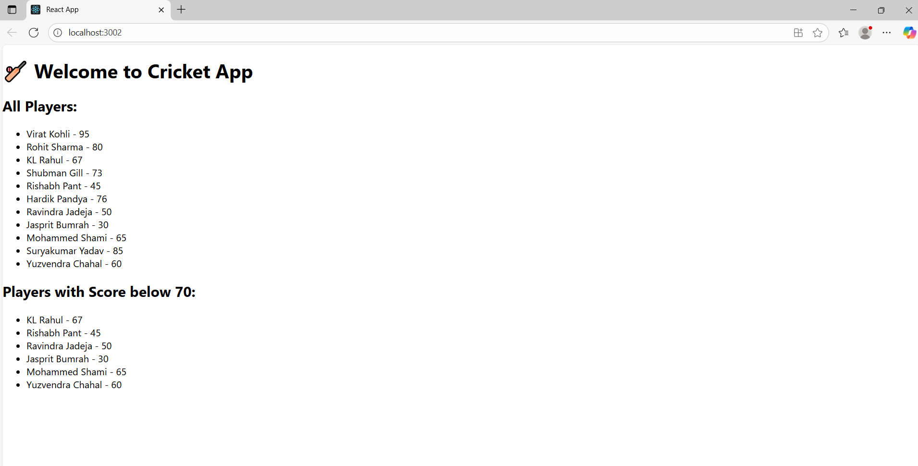

S.NO:2 EX.NO:10 Create a React Application named “officespacerentalapp” which uses React JSX to create elements, attributes and renders DOM to display the page.

SOLUTION CODE:

**App.js:**

import React from "react";

import "./App.css";

function App() {

const office = {

name: "DBS",

rent: 50000,

address: "Chennai",

image:

"https://images.unsplash.com/photo-1581375277858-b22d6057f14e?fit=crop&w=800&q=80",

};

const rentColor = office.rent < 60000 ? "red" : "green";

return (

<div className="app-container">

<h1 className="page-heading">Office Space at Affordable Range</h1>

<div className="office-card">

<img

src={office.image}

alt={office.name}

className="office-image"

/>

<h2>Name: {office.name}</h2>

<p style={{ color: rentColor, fontWeight: "bold" }}>

Rent: Rs. {office.rent}

</p>

<p>Address: {office.address}</p>

</div>

</div>

);

}

export default App;

**App.css:**

.app-container {

text-align: center;

padding: 30px;

font-family: Arial, sans-serif;

}

.page-heading {

writing-mode: vertical-rl; /* makes the heading vertical like in your output */

text-orientation: mixed;

font-size: 24px;

font-weight: bold;

position: absolute;

left: 10px;

top: 20%;

}

.office-card {

display: inline-block;

border: 1px solid #ddd;

padding: 20px;

border-radius: 10px;

box-shadow: 2px 2px 10px #ccc;

margin-left: 150px;

}

.office-image {

width: 300px;

height: auto;

border-radius: 8px;

}

OUTPUT:

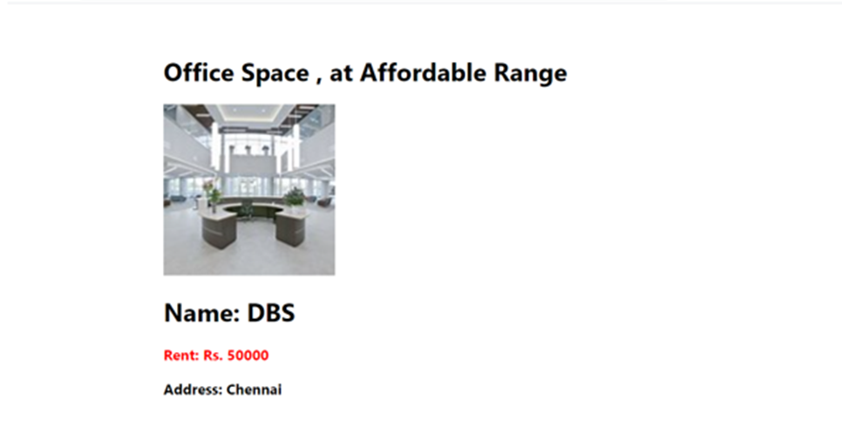

S.NO:3 EX.NO:11 Create a React Application “eventexamplesapp” to handle various events of the Form elements in HTML.

SOLUTION CODE:

**App.js:**

import React, { useState } from "react";

import CurrencyConvertor from "./CurrencyConvertor";

function App() {

const [count, setCount] = useState(1);

const increment = () => {

setCount(count + 1);

sayHello();

};

const decrement = () => {

setCount(count - 1);

};

const sayHello = () => {

console.log("Hello! Incremented value.");

};

const sayWelcome = () => {

alert("Welcome to React Events!");

};

const handleClick = () => {

alert("You clicked the button!");

};

return (

<div style={{ margin: "20px" }}>

<h3>{count}</h3>

<button onClick={increment}>Increment</button><br />

<button onClick={decrement}>Decrement</button><br />

<button onClick={sayWelcome}>Say welcome</button><br />

<button onClick={handleClick}>Click on me</button><br /><br />

<CurrencyConvertor />

</div>

);

}

export default App;

CurrencyConverter.js:

import React, { useState } from "react";

function CurrencyConvertor() {

const [amount, setAmount] = useState("");

const [currency, setCurrency] = useState("");

const handleSubmit = (e) => {

e.preventDefault();

let convertedAmount = 0;

if (currency.toLowerCase() === "euro") {

convertedAmount = parseFloat(amount) * 80;

alert(`Converting to Euro Amount is ${convertedAmount}`);

} else {

alert("Unsupported currency.");

}

};

return (

<div>

<h2 style={{ color: "darkgreen" }}>Currency Convertor!!!</h2>

<form onSubmit={handleSubmit}>

<div>

<label>Amount: </label>

<input

type="number"

value={amount}

onChange={(e) => setAmount(e.target.value)}

/>

</div>

<div>

<label>Currency: </label>

<input

type="text"

value={currency}

onChange={(e) => setCurrency(e.target.value)}

/>

</div>

<br />

<button type="submit">Submit</button>

</form>

</div>

);

}

export default CurrencyConvertor;

**OUTPUT:**

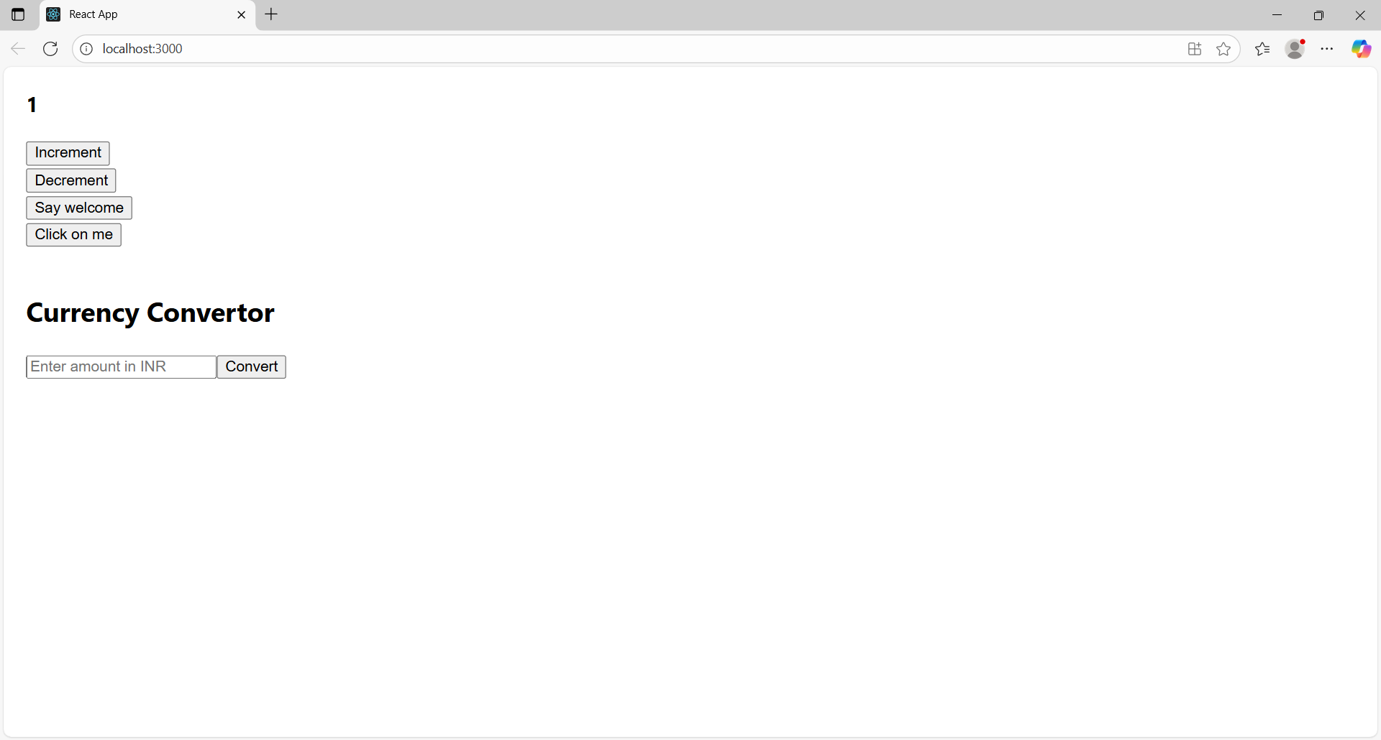

S.NO:4 EX.NO:12 Create a React Application named “ticketbookingapp” where the guest user can browse the page where the flight details are displayed whereas the logged in user only can book tickets.

SOLUTION CODE:

**App.js:**

import React, { useState } from "react";

// Greeting Components

function GuestGreeting() {

return <h2>Please sign up.</h2>;

}

function UserGreeting() {

return <h2>Welcome back</h2>;

}

function Greeting(props) {

const isLoggedIn = props.isLoggedIn;

return isLoggedIn ? <UserGreeting /> : <GuestGreeting />;

}

function LoginButton(props) {

return (

<button onClick={props.onClick}>

Login

</button>

);

}

function LogoutButton(props) {

return (

<button onClick={props.onClick}>

Logout

</button>

);

}

function App() {

const [isLoggedIn, setIsLoggedIn] = useState(false);

const handleLoginClick = () => setIsLoggedIn(true);

const handleLogoutClick = () => setIsLoggedIn(false);

return (

<div style={{ textAlign: "center", marginTop: "50px" }}>

<Greeting isLoggedIn={isLoggedIn} />

{isLoggedIn ? (

<LogoutButton onClick={handleLogoutClick} />

) : (

<LoginButton onClick={handleLoginClick} />

)}

</div>

);

}

export default App;

**OUTPUT:**

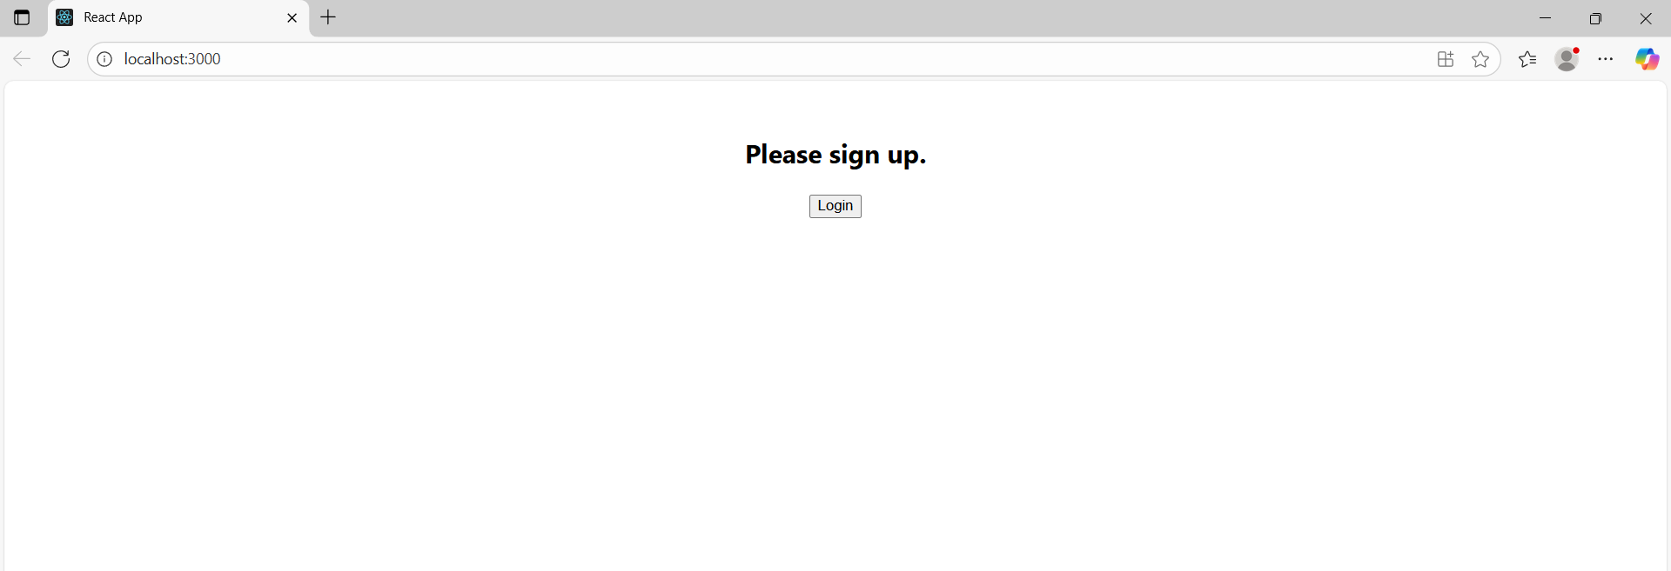

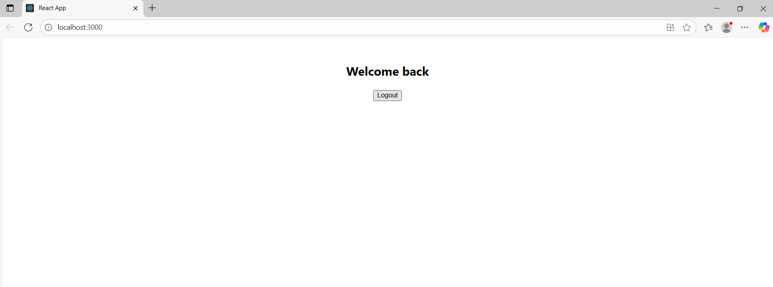

S.NO:5 EX.NO:13 Create a React App named “bloggerapp” in with 3 components.

SOLUTION CODE:

**BookDetails.js**:

import React from "react";

function BookDetails({ show }) {

const books = [

{ id: 1, bname: "Master React", price: 670 },

{ id: 2, bname: "Deep Dive into Angular 11", price: 800 },

{ id: 3, bname: "Mongo Essentials", price: 450 },

];

return show && (

<div>

<h2>Book Details</h2>

{books.map((book) => (

<div key={book.id}>

<h3>{book.bname}</h3>

<h4>{book.price}</h4>

</div>

))}

</div>

);

}

export default BookDetails;

BlogDetails.js:

import React from "react";

function BlogDetails({ show }) {

return show ? (

<div>

<h2>Blog Details</h2>

<h3>React Learning</h3>

<strong>Stephen Biz</strong>

<p>Welcome to learning React!</p>

<h3>Installation</h3>

<strong>Schwezdenier</strong>

<p>You can install React from npm.</p>

</div>

) : null;

}

export default BlogDetails;

**CourseDetails.js**:

import React from "react";

function CourseDetails({ show }) {

const courses = [

{ id: 1, cname: "Angular", date: "4/5/2021" },

{ id: 2, cname: "React", date: "6/3/202001" },

];

if (!show) return null;

return (

<div>

<h2>Course Details</h2>

{courses.map((course) => (

<div key={course.id}>

<h3>{course.cname}</h3>

<p>{course.date}</p>

</div>

))}

</div>

);

}

export default CourseDetails;

**App.js:**

import React, { useState } from "react";

import CourseDetails from "./components/CourseDetails";

import BookDetails from "./components/BookDetails";

import BlogDetails from "./components/BlogDetails";

function App() {

const [showCourse, setShowCourse] = useState(true);

const [showBook, setShowBook] = useState(true);

const [showBlog, setShowBlog] = useState(true);

return (

<div style={{ padding: "20px" }}>

<h1>Blogger App</h1>

<div style={{ display: "flex", justifyContent: "space-between", alignItems: "flex-start" }}>

<CourseDetails show={showCourse} />

<BookDetails show={showBook} />

<BlogDetails show={showBlog} />

</div>

<div style={{ marginTop: "20px" }}>

<button onClick={() => setShowCourse(!showCourse)}>Toggle Course</button>

<button onClick={() => setShowBook(!showBook)}>Toggle Book</button>

<button onClick={() => setShowBlog(!showBlog)}>Toggle Blog</button>

</div>

</div>

);

}

export default App;

**OUTPUT:**

